Experiment No. 1

Aim: Select a dataset and perform exploratory data analysis using Python(data preprocessing, transformation, discretization and visualisation )

Theory:
A) DISCRETIZATION:
Data discretization refers to a method of converting a huge
number of data values into smaller ones so that the evaluation
and management of data become easy. In other words, data
discretization is a method of converting attributes values of
continuous data into a finite set of intervals with minimum data
loss.
There are two forms of data discretization: first is
supervised discretization, and the second is unsupervised
discretization. Supervised discretization refers to a method in
which the class data is used. Unsupervised discretization refers to
a method depending upon the way which operation proceeds. It
means it works on the top-down splitting strategy and bottom-up
merging strategy.

SOME FAMOUS TECHNIQUES IN DATA DISCRETIZATION:
1. Histogram analysis
Histogram refers to a plot used to represent the underlying
frequency distribution of a continuous data set. Histogram assists
the data inspection for data distribution. For example, Outliers,
skewness representation, normal distribution representation, etc.
2. Binning
Binning refers to a data smoothing technique that helps to group
a huge number of continuous values into smaller values. For data
discretization and the development of idea hierarchy, this
technique can also be used.
3. Cluster Analysis
Cluster analysis is a form of data discretization. A clustering
algorithm is executed by dividing the values of x numbers into
clusters to isolate a computational feature of x. 4. Data discretization using decision tree analysis
Data discretization refers to a decision tree analysis in which a
top-down slicing technique is used. It is done through a
supervised procedure. In a numeric attribute discretization, first,
you need to select the attribute that has the least entropy, and
then you need to run it with the help of a recursive process. The
recursive process divides it into various discretized disjoint
intervals, from top to bottom, using the same splitting criterion.
5. Data discretization using correlation analysis
Discretizing data by linear regression technique, you can get the
best neighboring interval, and then the large intervals are
combined to develop a larger overlap to form the final 20
overlapping intervals. It is a supervised procedure.

B) DATA VISUALIZATION:
Data visualization is the graphical representation of information
and data. By using visual elements like chats, graphs and maps,
data visualization tools provide an accessible way to see and
understand trends, outliers, and patterns in data.
In the world of Big Data, data visualization tools and technologies
are essential to analyze massive amounts of information and
make data-driven decisions.

Types of data visualization charts : -

Now that we understand how data visualization can be used, let’s
apply the different types of data visualization to their uses. There
are numerous tools available to help create data visualizations.
Some are more manual and some are automated, but either way
they should allow you to make any of the following types of
visualizations.

1. Line chart
A line chart illustrates changes over time. The x-axis is usually a
period of time, while the y-axis is quantity. So, this could
illustrate a company’s sales for the year broken down by month
or how many units a factory produced each day for the past
week.

2. Area chart
An area chart is an adaptation of a line chart where the area under the line is filled in to emphasize its significance. The color fill for the area under each line should be somewhat transparent so that overlapping areas can be discerned.

3. Bar chart
A bar chart also illustrates changes over time. But if there is more
than one variable, a bar chart can make it easier to compare the
data for each variable at each moment in time. For example, a
bar chart could compare the company’s sales from this year to
last year.

4. Histogram
A histogram looks like a bar chart, but measures frequency rather
than trends over time. The x-axis of a histogram lists the “bins”
or intervals of the variable, and the y-axis is frequency, so each
bar represents the frequency of that bin. For example, you could
measure the frequencies of each answer to a survey question.
The bins would be the answer: “unsatisfactory,” “neutral,” and
“satisfactory.” This would tell you how many people gave each
answer.

5. Scatter plot
Scatter plots are used to find correlations. Each point on a scatter
plot means “when x = this, then y equals this.” That way, if the
points trend a certain way (upward to the left, downward to the
right, etc.) there is a relationship between them. If the plot is
truly scattered with no trend at all, then the variables do not
affect each other at all.

6. Bubble chart
A bubble chart is an adaptation of a scatter plot, where each
point is illustrated as a bubble whose area has meaning in
in addition to its placement on the axes. A pain point associated
with bubble charts is the limitations on sizes of bubbles due to the
limited space within the axes. So, not all data will fit effectively in
this type of visualization.

7. Pie chart
A pie chart is the best option for illustrating percentages, because
it shows each element as part of a whole. So, if your data
explains a breakdown in percentages, a pie chart will clearly
present the pieces in the proper proportions.

8. Gauge
A gauge can be used to illustrate the distance between intervals.
This can be presented as a round clock-like gauge or as a tube
type gauge resembling a liquid thermometer. Multiple gauges can
be shown next to each other to illustrate the difference between
multiple intervals.

9. Map
Much of the data dealt with in businesses has a location element,
which makes it easy to illustrate on a map. An example of a map
visualization is mapping the number of purchases customers
made in each state in the U.S. In this example, each state would
be shaded in and states with less purchases would be a lighter
shade, while states with more purchases would be darker shades.
Location information can also be very valuable for business
leadership to understand, making this an important data
visualization to use.

10. Heat map
A heat map is basically a color-coded matrix. A formula is used to
color each cell of the matrix and is shaded to represent the
relative value or risk of that cell. Usually heat map colors range
from green to red, with green being a better result and red being
worse. This type of visualization is helpful because colors are
quicker to interpret than numbers.

11. Frame diagram
Frame diagrams are basically tree maps which clearly show
hierarchical relationship structure. A frame diagram consists of
branches, which each have more branches connecting to them
with each level of the diagram consisting of more and more
branches.

Code:
import pandas as pd
import numpy as np
import matplotlib.pyplot as plt
import seaborn as sns
from sklearn.preprocessing import MinMaxScaler,
StandardScaler
# Load the dataset
data = pd.read_csv("100 Sales Records.csv") # Replace
with the actual dataset filename
# Check for missing values
missing_values = data.isnull().sum()
print("Missing Values:")
print(missing_values)
# Data Transformation
# Min-Max Normalization
numerical_features = ["Unit Price", "Unit Cost", "Total
Revenue", "Total Cost", "Total Profit"]
scaler = MinMaxScaler()
data[numerical_features] =
scaler.fit_transform(data[numerical_features])
# Z-Score Normalization
mean = data[numerical_features].mean()
std = data[numerical_features].std()
data[numerical_features] = (data[numerical_features] -
mean) / std
# Decimal Scaling (Choose a decimal point position)
decimal_point = 3
data[numerical_features] = data[numerical_features] /
10**decimal_point
# Data Discretization (Binning - choose the number of
bins)
num_bins = 5
data['Total Revenue Binned'] = pd.cut(data['Total
Revenue'], bins=num_bins, labels=False)
data['Total Cost Binned'] = pd.cut(data['Total Cost'],
bins=num_bins, labels=False)
data['Total Profit Binned'] = pd.cut(data['Total Profit'],
bins=num_bins, labels=False)
# Data Analysis and Visualization
# Summary Statistics
summary_stats = data.describe()
print("Summary Statistics:")
print(summary_stats)
# Histograms
data[numerical_features].hist(bins=20, figsize=(12, 8))
plt.suptitle("Histograms of Numerical Features")
plt.show()
# Box Plots
sns.set(style="whitegrid")
plt.figure(figsize=(12, 8))
sns.boxplot(data=data[numerical_features])
plt.title("Box Plots of Numerical Features")
plt.xticks(rotation=45)
plt.show()
# Pairplot for correlations
sns.pairplot(data[numerical_features], diag_kind="kde")
plt.suptitle("Pairplot of Numerical Features")
plt.show()
# Correlation Matrix
correlation_matrix = data[numerical_features].corr()
plt.figure(figsize=(10, 6))
sns.heatmap(correlation_matrix, annot=True,
cmap="coolwarm", linewidths=.5)
plt.title("Correlation Matrix")
plt.show()
# Grouping and Aggregation (Example: Average Total Profit
by Order Priority)
average_profit_by_priority = data.groupby('Order
Priority')['Total Profit'].mean().reset_index()
print("Average Total Profit by Order Priority:")
print(average_profit_by_priority)

Output:

Missing Values:
Region 0
Country 0
Item Type 0
Sales Channel 0
Order Priority 0
Order Date 0
Order ID 0
Ship Date 0
Units Sold 0
Unit Price 0
Unit Cost 0
Total Revenue 0
Total Cost 0
Total Profit 0
dtype: int64
Summary Statistics:
Order ID Units Sold Unit Price Unit
Cost Total Revenue Total Cost Total Profit Total
Revenue Binned Total Cost Binned Total Profit Binned
count 1.000000e+02 100.000000 1.000000e+02
1.000000e+02 1.000000e+02 1.000000e+02 1.000000e+02
100.000000 100.000000 100.000000
mean 5.550204e+08 5128.710000 1.734723e-19 -5.204170e-
20 -3.903128e-20 1.452831e-19 7.155734e-20
0.740000 0.660000 0.880000
std 2.606153e+08 2794.484562 1.000000e-03 1.000000e-
03 1.000000e-03 1.000000e-03 1.000000e-03
1.106637 1.056199 1.191553
min 1.146066e+08 124.000000 -1.135145e-03 -9.783209e-
04 -9.373908e-04 -8.563158e-04 -1.004301e-03
0.000000 0.000000 0.000000
25% 3.389225e+08 2836.250000 -8.278341e-04 -8.246613e-
04 -7.566745e-04 -7.038571e-04 -7.302411e-04
0.000000 0.000000 0.000000
50% 5.577086e+08 5382.500000 -4.112245e-04 -4.451082e-
04 -4.254528e-04 -5.242359e-04 -3.441299e-04
0.000000 0.000000 0.000000
75% 7.907551e+08 7369.000000 6.810016e-04 3.840534e-
04 5.743428e-04 6.292462e-04 4.427139e-04
1.000000 1.000000 1.000000
max 9.940222e+08 9925.000000 1.661806e-03 1.774163e-
03 3.166765e-03 3.300915e-03 2.914777e-03
4.000000 4.000000 4.000000
C:\Users\umesh\AppData\Local\Programs\Python\Python311\Lib
\site-packages\seaborn\axisgrid.py:118: UserWarning: The
figure layout has changed to tight
self._figure.tight_layout(*args, **kwargs)
Average Total Profit by Order Priority:
Order Priority Total Profit
0 C -0.000308
1 H 0.000277
2 L -0.000090
3 M 0.000043

Histogram
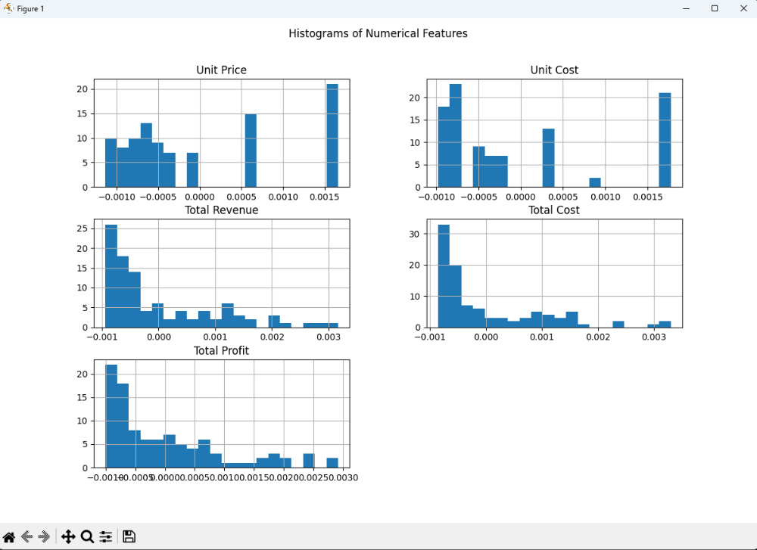
Boxplot
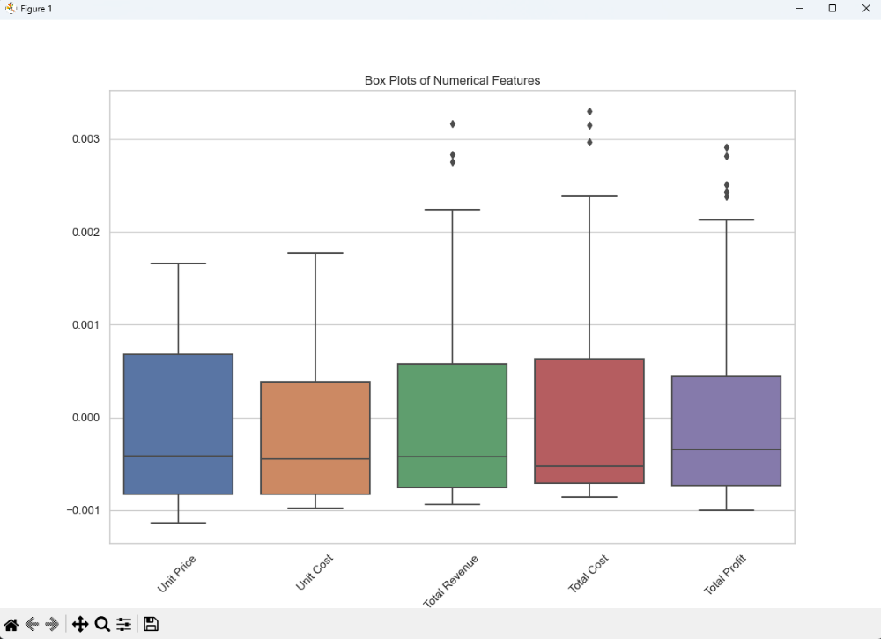
Pairplot
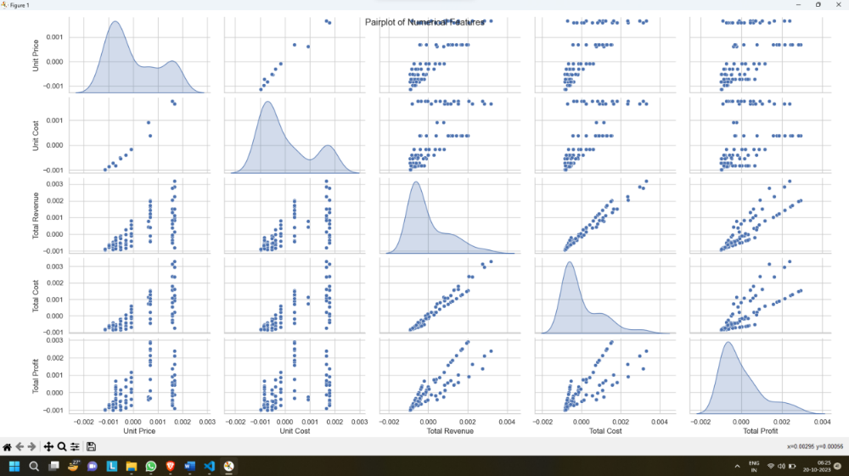

Correlation matrix
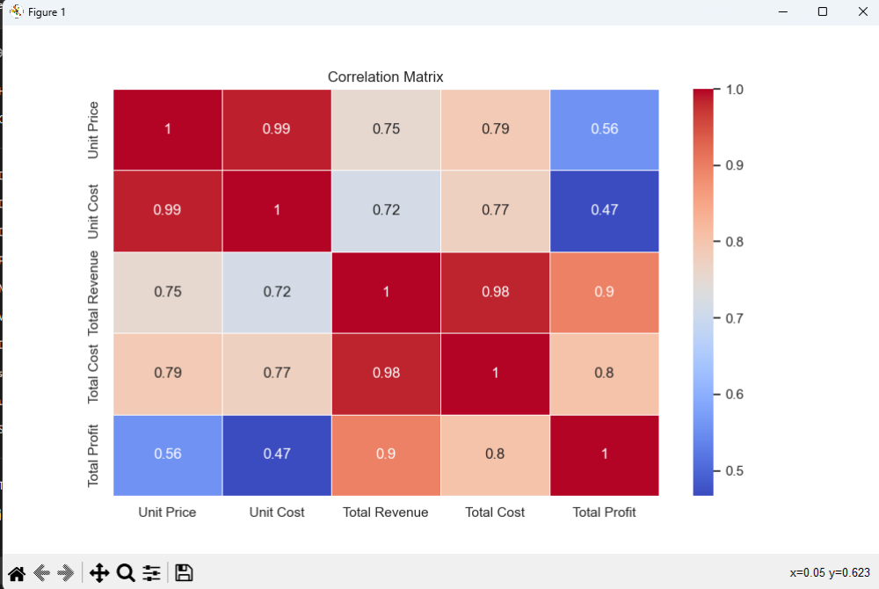

Conclusion: Thus, we implemented exploratory data analysis using Python(data preprocessing, transformation, discretization and visualisation).

